Name :Sk.Kashifa

Registration no :192121135

Foreign trading system :

Class diagram :

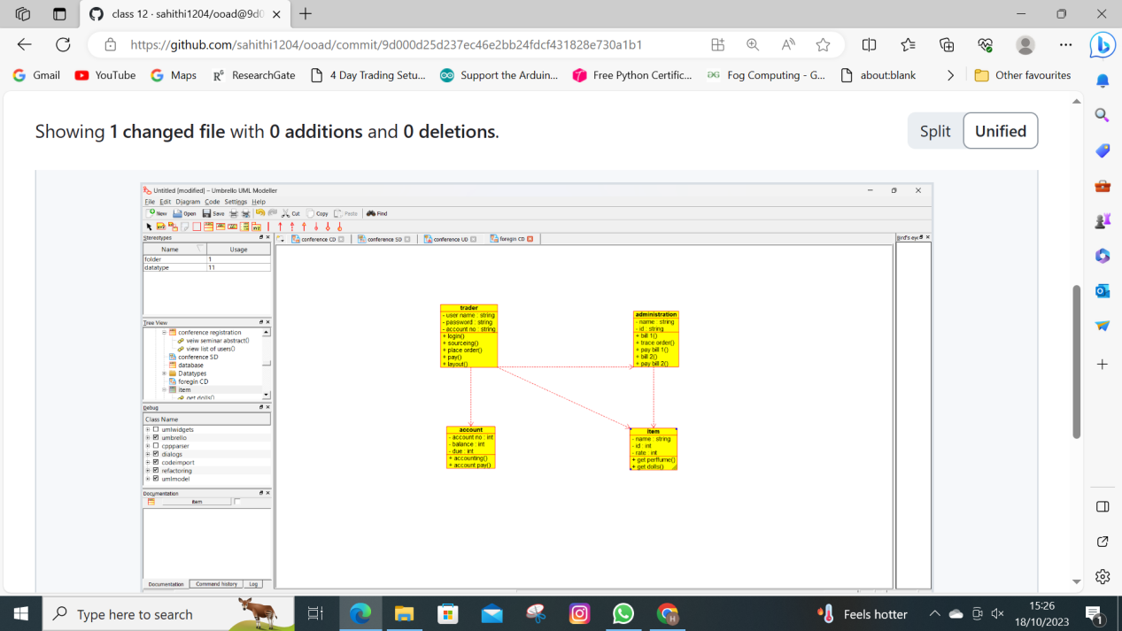

Activity diagram :

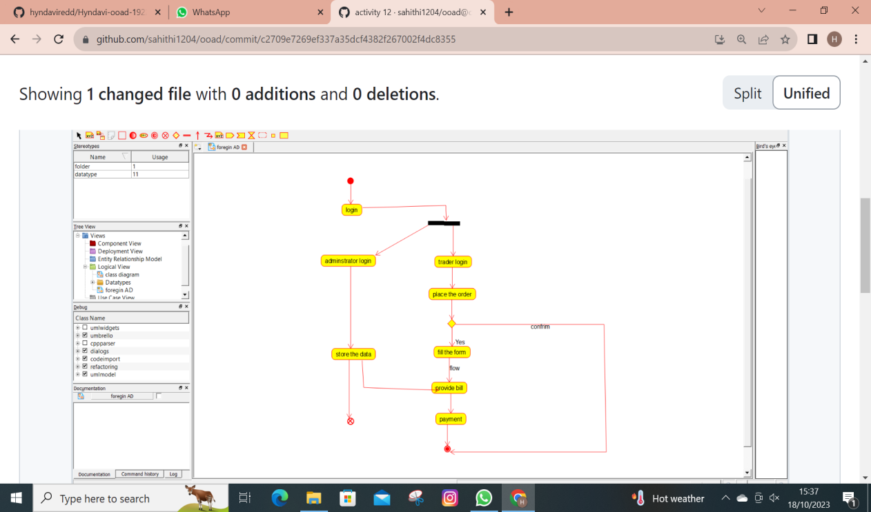

Usecase Diagram :

